# Macintosh HD:Users:z018620:Dev:Helps:Icons:RapiTag:RapiTagAppIcon-01.pngRapiTag – User Guide

Version 1.1

12/23/2016

## Introduction

RapiTag is a standalone application for encoding RFID EPC test tags using the encodings used in Target’s supply chain. It works with proprietarily encoded EPC GIDs that contain Target’s DPCI number, as well as national brand merchandize that uses an EPC encoded, serialized GTIN, or SGTIN. The app scans the target RFID EPC tag, and can scan printed bar codes on both blank RFID tags or UPC product labels or or accept direct user input. Once all data has been collected, DPCI + Serial Number or GTIN + Serial Number, the encode button is enabled and you can encode the tag. Upon success, a green check is displayed and the serial number is incremented by one. If not, a red circle with a line through it is displayed.

## Requirements

An iOS device (iPod, iPhone, iPad) running iOS 9.x or higher (for Data Matrix barcodes)

A supported RFID reader – one of:

* Zebra RFD8500
* Intertek uGrokit GR-1.5-915

Use MyAccess to join: App-RapiTag-User

The RapiTag application from the Target Application Zone (TAZ)

## Setup

Launch TAZ and download and install RapiTag

Before launching RapiTag, you must connect a reader

* For the uGrokit reader, plug it into the headphone jack
* 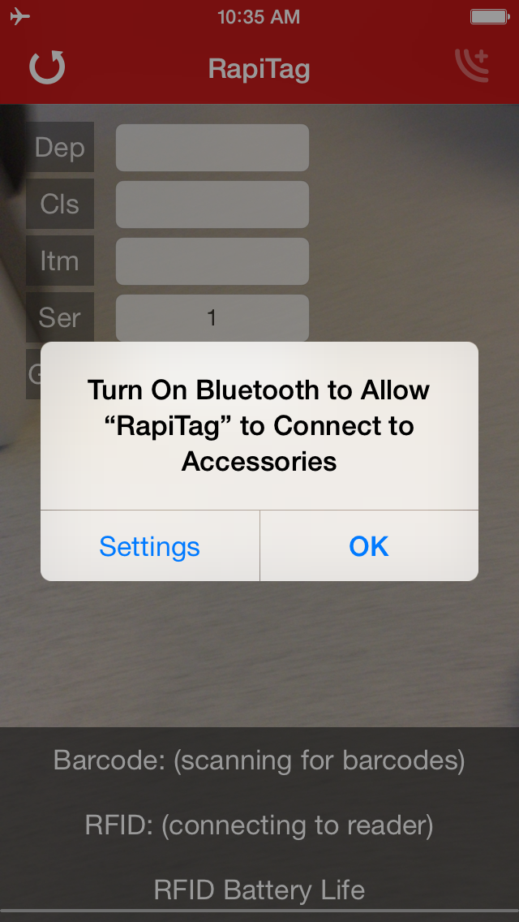For the Zebra reader, use iOS Settings to connect via Bluetooth

Note: If you are NOT using a Bluetooth reader, you can disregard the Bluetooth warning dialog presented at start up (if your Bluetooth is disabled). Just click OK.

If you are using a Bluetooth reader, click on the settings button and configure Bluetooth as outlined in the next section

## Bluetooth Setup

### On the RFID reader

Turn on the Bluetooth reader

Press and hold the Bluetooth paring setup button until the blue light is flashing slowly (if you just turned it on, or installed a new battery, it may already be flashing)

### On the iOS device

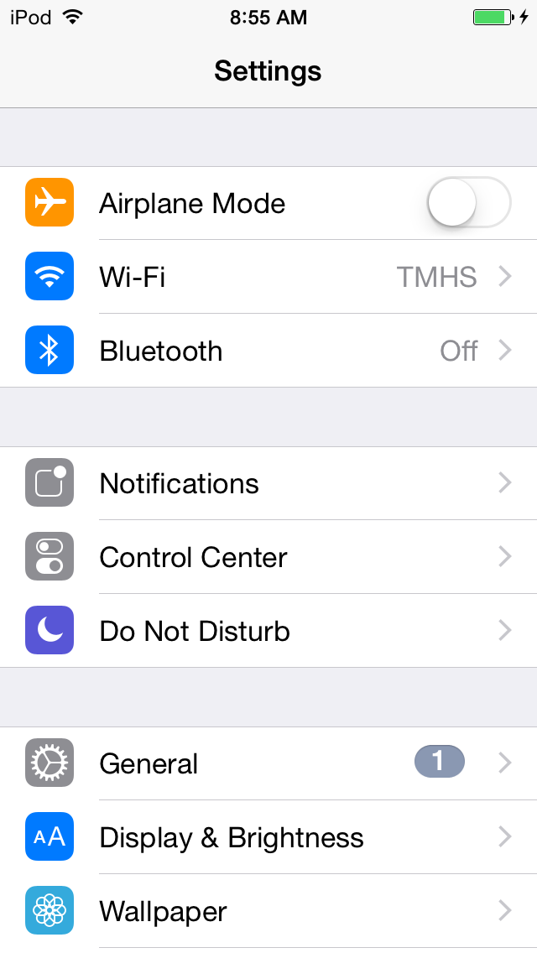

Open Settings and click on Bluetooth:

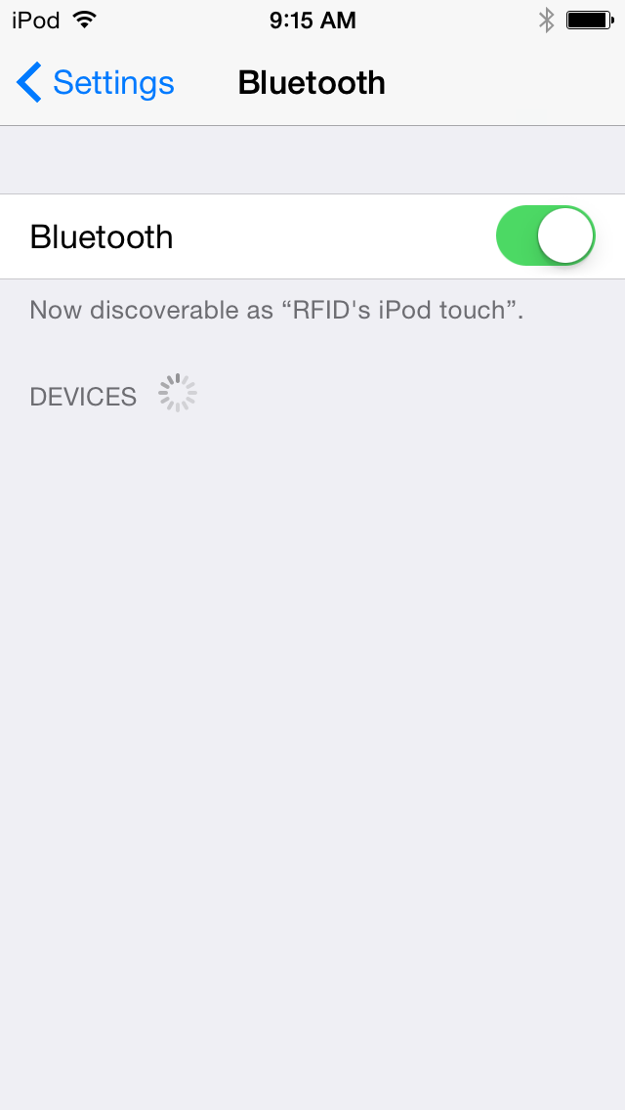Make sure Bluetooth is on:

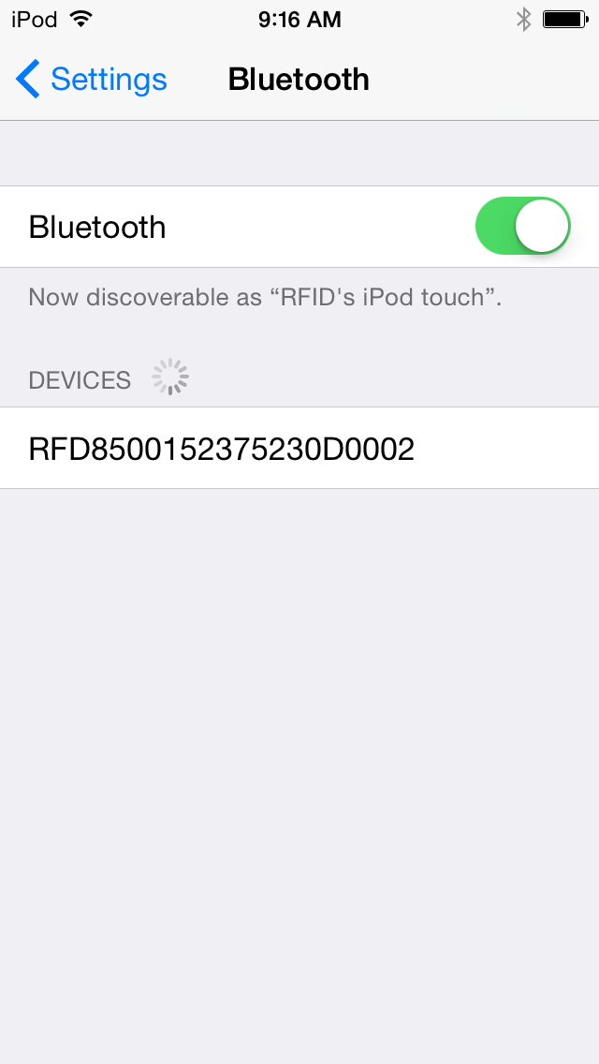

With the blue Bluetooth pairing light flashing on the RFID handheld, select the RFID device in the devices list:

### On the RFID reader

The Bluetooth pairing light will now begin flashing more quickly. Pull the trigger on the handheld to confirm pairing (this is a security feature – you must have physical possession of both devices to successfully pair them).

### Macintosh HD:Users:z018620:Pictures:iPhoto Library.photolibrary:Masters:2015:09:21:20150921-091654:IMG_0014.PNGOn the iOS device

The RFID device should now show as connected. If not, repeat the steps in this section until a successful connection is established:

You should now be paired, and can open the application.

## Launch RapiTag

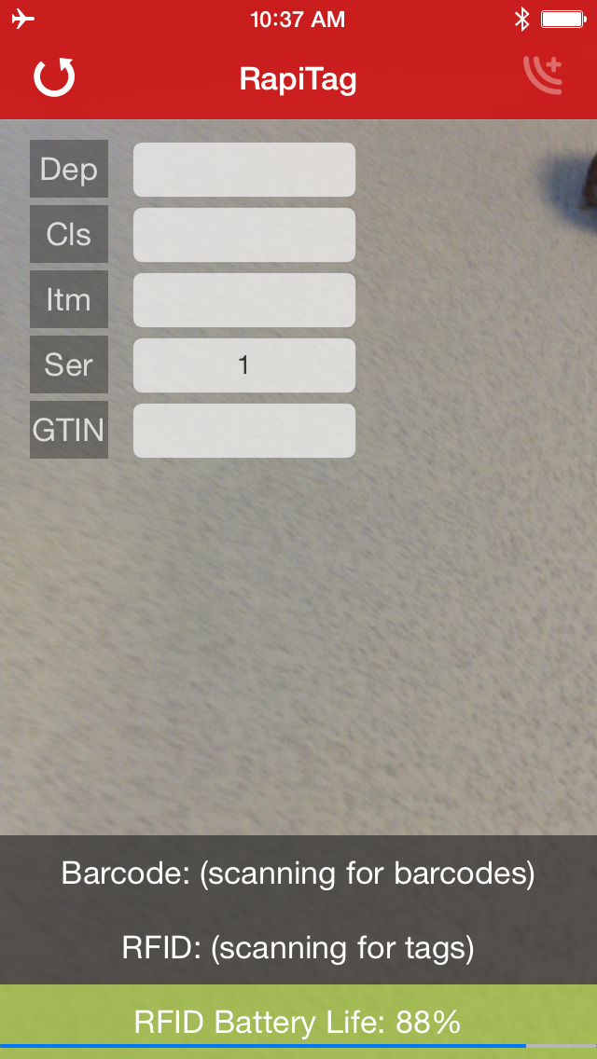If the reader was connected, you should see the RFID Battery Life displayed (see troubleshooting if not), and the RFID label should say “Scanning for tags” (see troubleshooting if not):

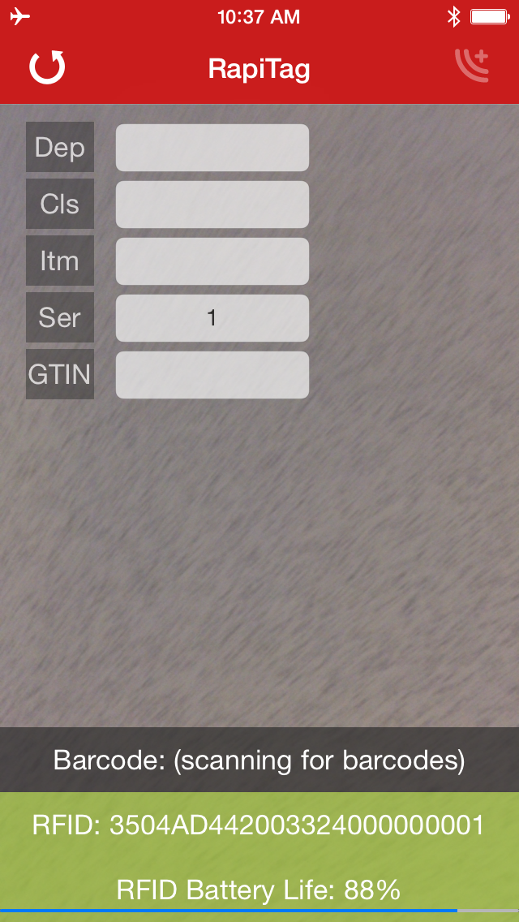If an RFID tag was already read, it will be displayed:

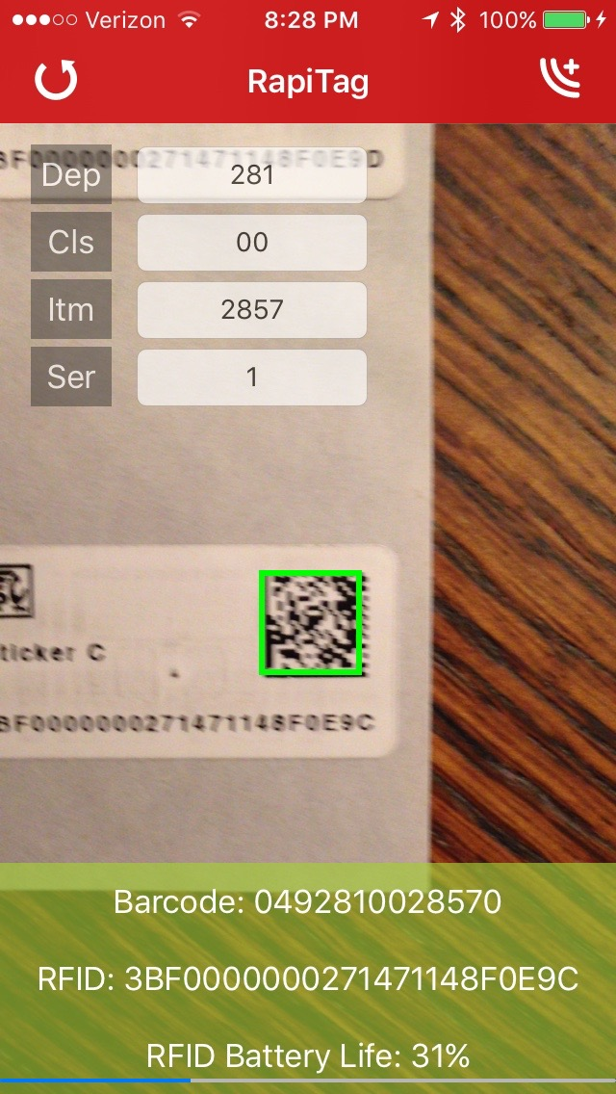If you want to do scan scan using the printed barcode on the blank RFID label, position the tag for the camera to scan that barcode:

If you want to enter product data from an existing UPC/EAN barcode, position the barcode for the camera to read it. Once read, you will see a green rectangle on the barcode image and the number will be displayed.

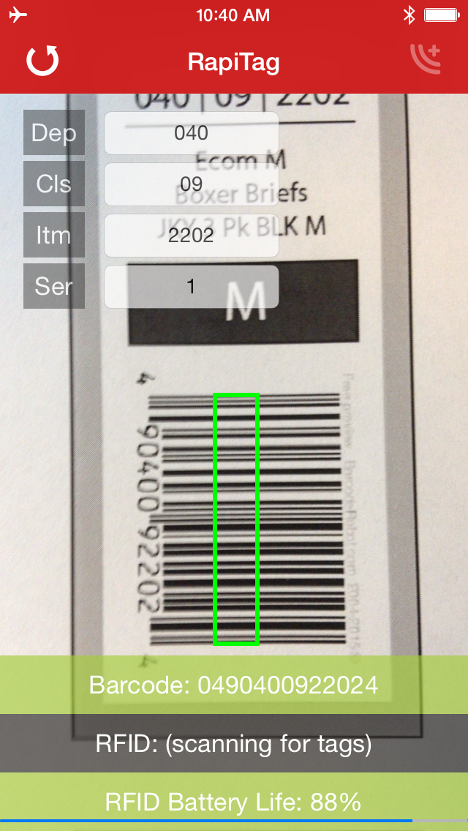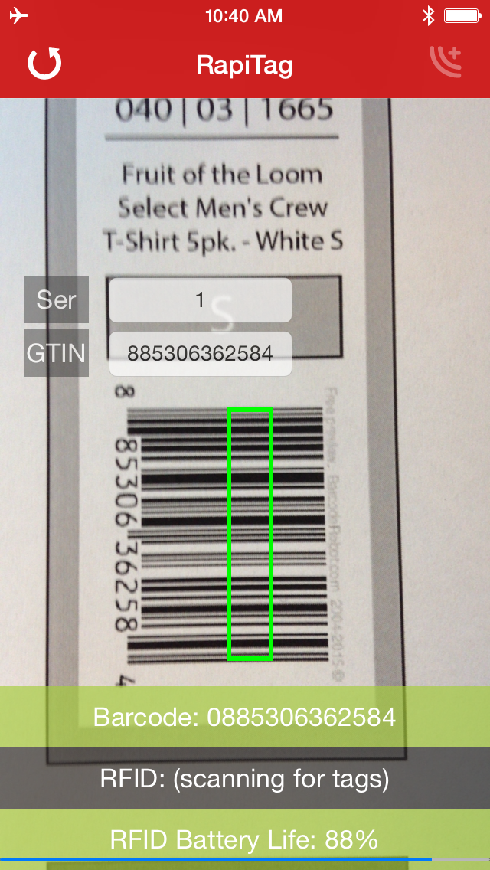All of the input fields will also be populated. If it is a DPCI, then the GTIN input will be hidden. If it is a GTIN, then the DPCI input fields will be hidden.

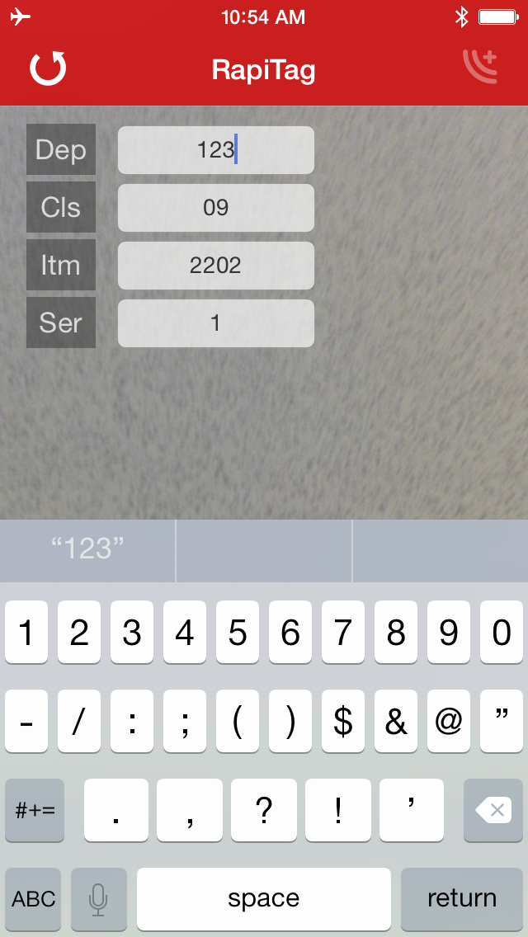You can click on any field and manually enter data as well. You must hit “return” to accept any changes.

If you are encoding a replacement tag, you MUST use GID encodings, even if the tag is a GTIN. To do this, turn the device sideways so you can see the “Replacement” switch and turn it on. This overrides the default and encodes national brand GTINs using the Target proprietary GID encoding scheme. The serial number for replacement tags MUST start with ’01’, ‘02’, ’03’, or ‘04’, indicating the provisioning authority:

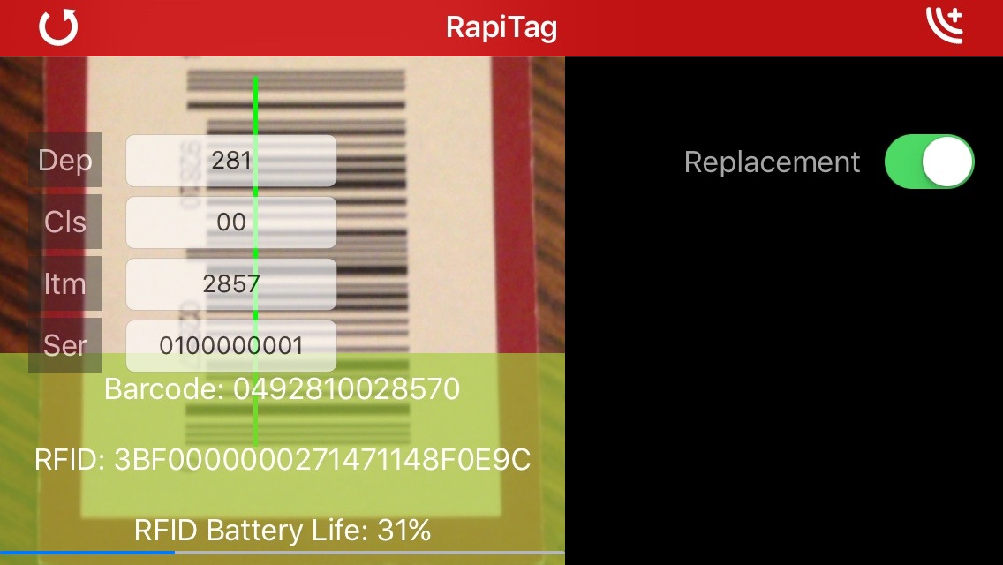

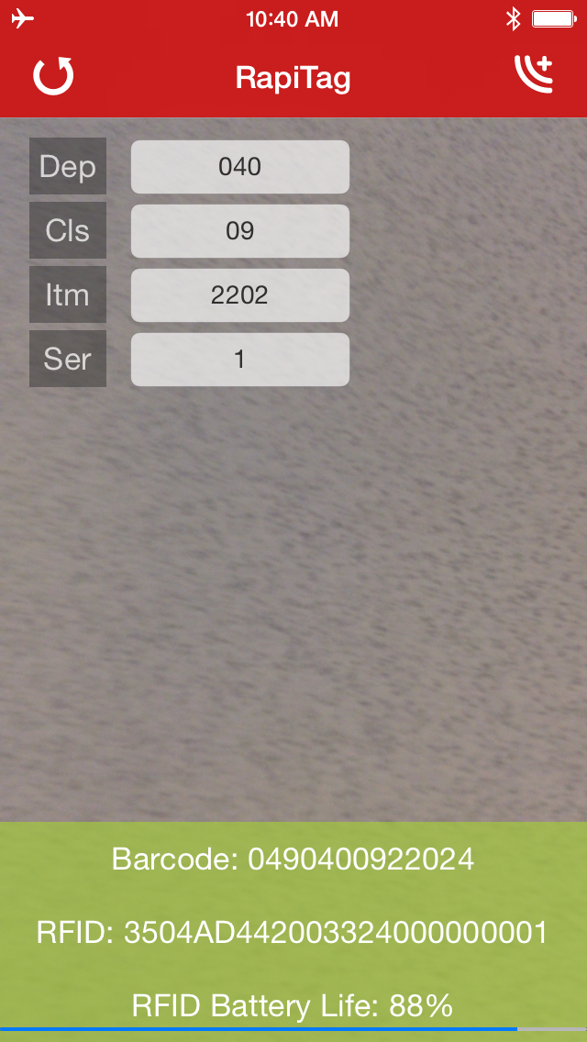Once both the EPC tag is read, and the proper input collected, the Encode button in the upper right is enabled:

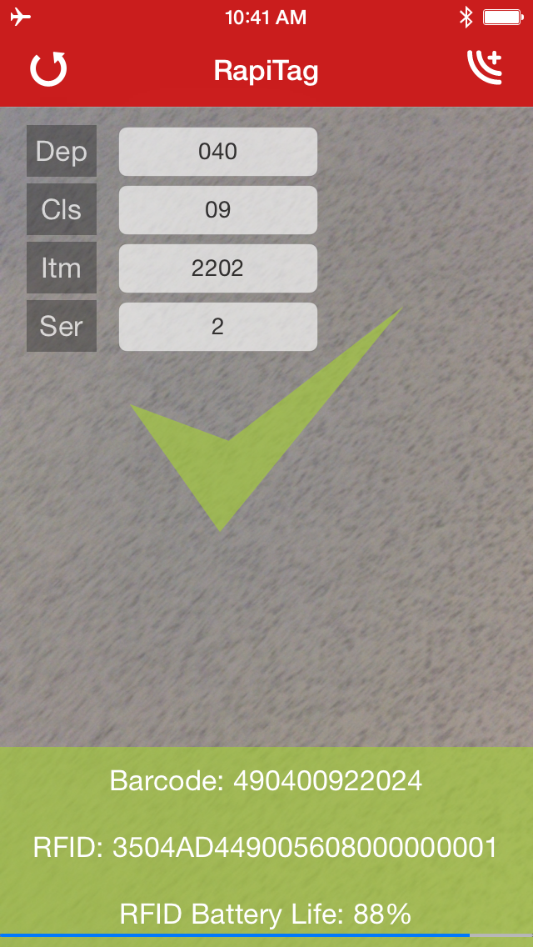Keeping the EPC tag in range, if you press the encode button, RapiTag will attempt to encode the tag. If successful, a green check mark is displayed and the Barcode and RFID fields will be green. The serial number will be automatically incremented by 1 to facilitate rapid encoding:

If it fails, then a red circle with a line through it will be displayed, and the Barcode and RFID fields will be red.

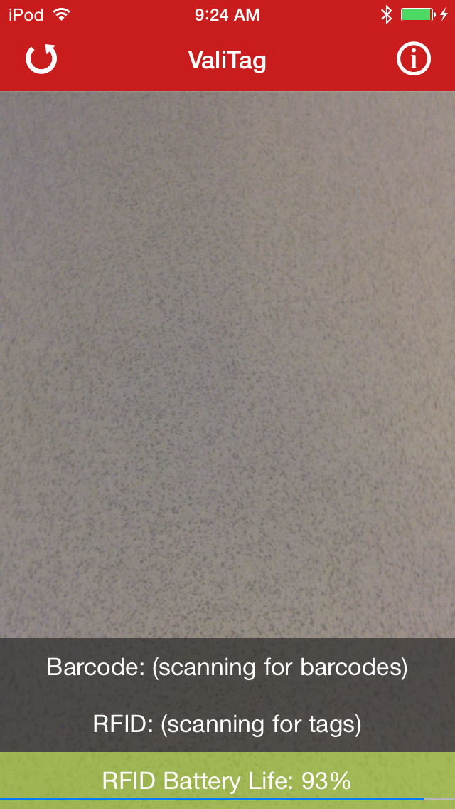

To read another tag, or start over, press the reset button on the upper left:

Important note: the power settings on the RFID reader have been turned down enough so that only tags within the immediate range of the reader will be read and encoded. You should be able to keep tags at arm’s reach away on either side and they won’t be affected, but occasionally they are. You may need to test this in your environment until you are sure you are reading and encoding only the RFID tag that is in range. To keep the application simple, these settings are not configurable.

When the battery of the reader gets too low, charge it (or in the case of the Zebra reader, replace the battery).

## Basic Troubleshooting

* **No Battery life displayed**
  + This can be an indication that the reader is not properly connected, but not all readers report their battery life in the same manner, so it is not a guarantee.
  + Check the reader connections (headphone plug or Bluetooth)
* **Connecting to reader message**
  + If this message is displayed, press the reset button in the upper left and try again.
  + This is more often an issue with a Bluetooth reader.
  + If after a couple of resets it still won’t connect
    - If you are using an attached reader, check the plug connection and restart
    - If you are using a Bluetooth reader, proceed to the next step
* **Bluetooth connection fails**
  + Exit RapiTag
  + Go into iOS Settings, Bluetooth and click on the ‘i’ button to the right of the RFID reader
  + Select “Forget this Device” and accept

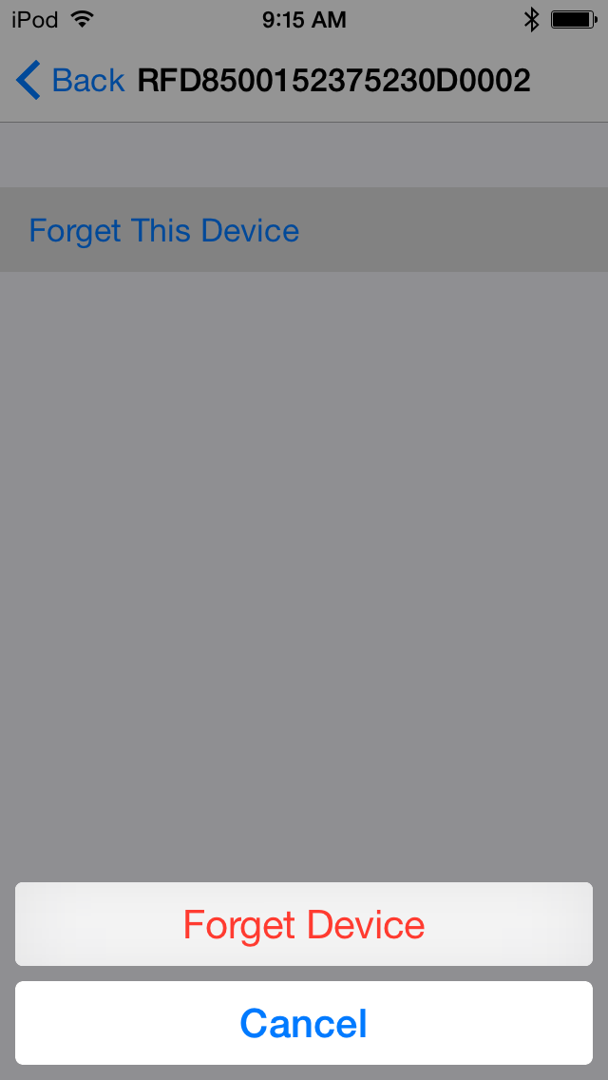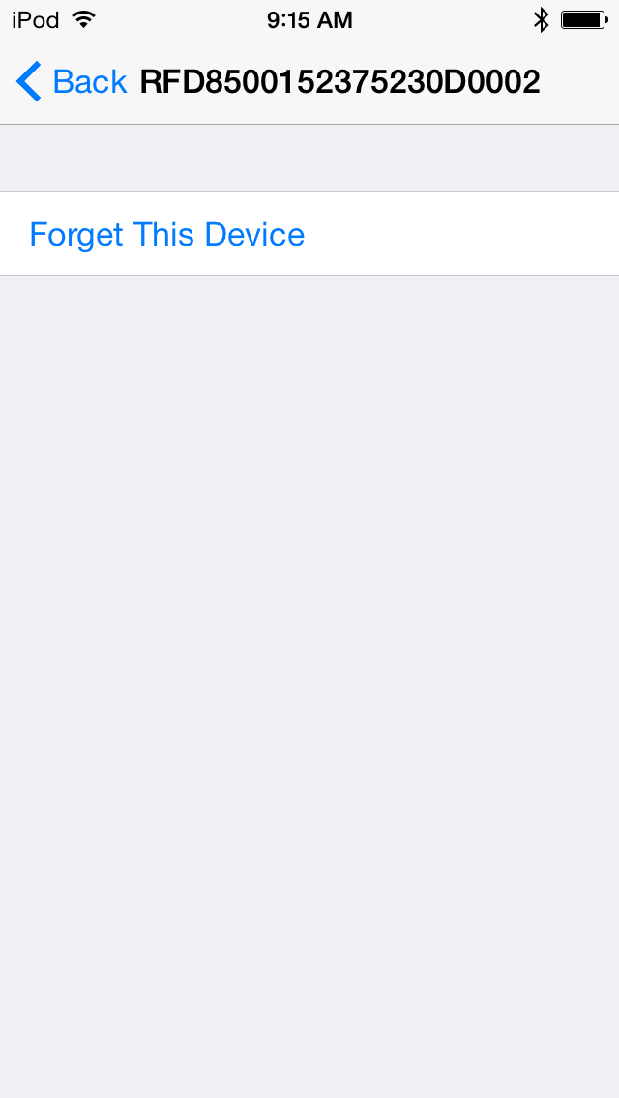

* + Once forgotten, go through the setup steps outlined in “Bluetooth Setup” to reconnect the reader.
  + Wait until it is connected and then relaunch RapiTag.
  + The reader should connect automatically.